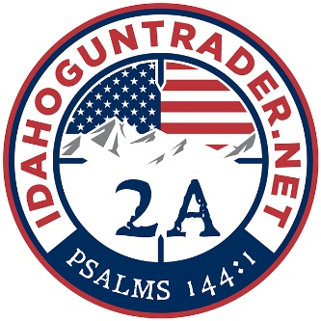

IDAHO FIREARM BILL OF SALE

Date: [DATE]

- THE PARTIES.

Buyer’s Name: [BUYER'S NAME] with a mailing address of [ADDRESS] ("Buyer").

Seller’s Name: [SELLER'S NAME] with a mailing address of [ADDRESS] ("Seller").

- FIREARM DETAILS.

Make: [MAKE] Type/Model: [TYPE/MODEL]

Caliber: [CALIBER] Serial Number (SN): [SERIAL NUMBER]

Hereinafter known as the “Firearm.”

- PURCHASE. check one (1)

☐ - Seller accepts cash payment in the amount of $[PURCHASE PRICE] to be paid on:
☐ - The date of this bill of sale.

☐ - At a future date no later than [DATE]

☐ - Other. [OTHER]

☐ - Buyer is receiving the Firearm as a Gift.

☐ - Seller accepts trade for the Firearm in exchange for: [ENTER TRADE]

- SELLER’S DISCLOSURE.

- Seller has verified that the Firearm details are correct;
- Seller acknowledges the Firearm’s serial number is legible;
- Seller acknowledges that they are the lawful owner of the Firearm;
- Seller claims to have the right to sell the Firearm;
- Seller has no knowledge of defects in the Firearm;
- Seller believes the Firearm is fit to be used for its intended purpose;
- Seller has never been used in a manner of questionable or certain illegality; and
- Seller assumes no responsibility after the transfer of ownership has taken place.

- BUYER’S DISCLOSURE.

- Buyer is not under the legal age to own a Firearm;
- Buyer is not being convicted of and never been convicted in any court of a crime punishable by imprisonment for a term exceeding one (1) year;
- Buyer is not a fugitive and has no outstanding warrants;
- Buyer is not an unlawful user of or addicted to any controlled substance;
- Buyer has never been adjudicated as a mental defective or has been committed to a mental institution;
- Buyer is not an alien illegally or unlawfully in the United states or an alien admitted to the United states under a nonimmigrant visa;
- Buyer has not been discharged from the Armed Forces under dishonorable conditions;
- Buyer is a citizen of the United states;
- Buyer is not subject to a court order that restrains the person from owning a Firearm;
- Buyer not been convicted of a misdemeanor crime of domestic violence;
- Buyer can lawfully receive, possess, ship, or transport a Firearm; and
- Buyer is not a person prohibited under State or Federal law from purchasing a Firearm.

- NO WARRANTY.

The undersigned Seller affirms that the above information about the Firearm is accurate to the best of their knowledge. The undersigned Buyer accepts receipt of this bill of sale and understands that the above Firearm is sold on an “as is, where is” condition with no guarantees or warranties, either expressed or implied.

Buyer’s Signature: ______________________________ Date: __________________

Print Name: ______________________________

Driver’s License Number: _________________________ State: __________________

Seller’s Signature: ______________________________ Date: __________________

Print Name: ______________________________

Driver’s License Number: _________________________ State: __________________

